 QUAID E AWAM UNIVERSITY OF 
ENGINEERING, SCIENCE AND TECHNOLOGE NAWABSHAH
Department of Artificial intelligence

Project Title: Employee Management System
Name: Jawaria Tariq
Roll no: 23BS(AI)-39
Date: September 3, 2024
Instructor’s Name: Muhammad Owais Rehmani

Table of Content
1. Abstract 3
2. Introduction 3
Objectives 3
Technologies Used 4
3. System Design 4
Architecture 4
Use Case Diagram 5
Actors in the System: 5
Data Flow Diagrams (DFD) 5
Class Diagram 5
Entity-Relationship (ER) Diagram 5
Gantt Chart 6
4. Implementation 6
Modules/Features 6
- Add Employee 6
- View Employee 6
- Update Employee 6
- Remove Employee 7
- Attendance Tracking 7
5. Testing 7
Testing Approach 7
Test Cases 7
7. Future Enhancements 9

1. Abstract

The Employee Management System (EMS) is designed to simplify employee record management and attendance tracking. By automating processes such as adding, updating, and removing employees, and integrating attendance tracking with employee records, the EMS aims to reduce manual labor and ensure data consistency. Developed using Java (version 11) and SQL Workbench (version 8.0), the system provides HR departments with a robust tool for efficient employee management and data integrity.

2. Introduction

Objectives

The primary goal of the EMS is to offer a user-friendly solution for managing employee data and attendance. The system automates processes including the addition, updating, removal, and viewing of employee records while ensuring data integrity through unique ID generation and attendance tracking.

Scope
The EMS supports features such as employee registration, attendance tracking, and automatic employee ID generation. The system manages various data fields, including name, CNIC, designation, salary, qualification, phone number, and email.

Technologies Used
- Programming Language: Java (Version 11)
- Database: SQL Workbench (Version 8.0)
- Development Environment: Visual Studio Code

3. System Design

Architecture
The system employs a layered architecture, applying object-oriented programming (OOP) principles. The core class `Employee` stores general employee information, while attendance records are managed separately and linked via the employee's unique ID.

Use Case Diagram

Actors in the System:
- Admin/HR: Manage employees, track attendance, generate reports.
- Employee: View own attendance and personal details.
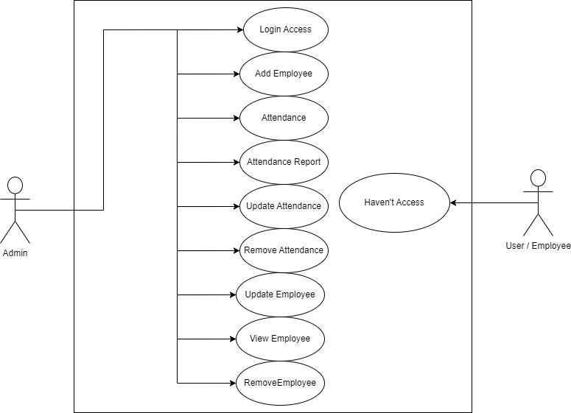

Data Flow Diagrams (DFD)

The DFD represents processes for adding, updating, viewing, and removing employees and their attendance records, illustrating how data flows between various system modules.
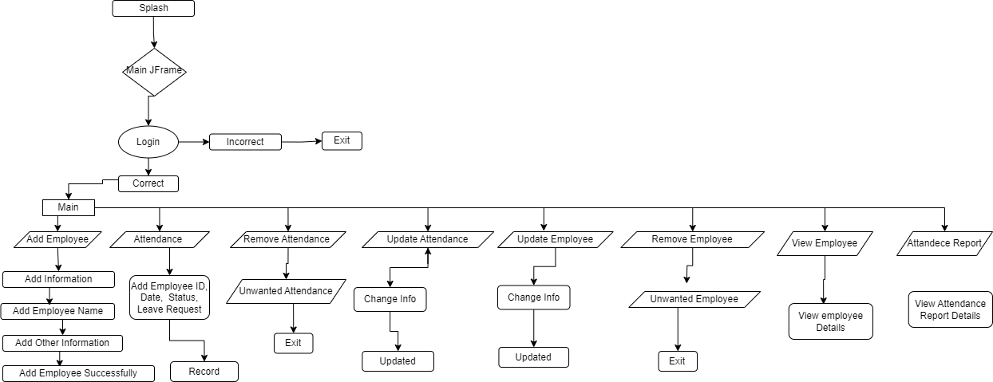

Class Diagram

The class diagram showcases the structure of the `Employee` and `Attendance` classes, highlighting their interactions and how attendance records are linked to employee IDs.
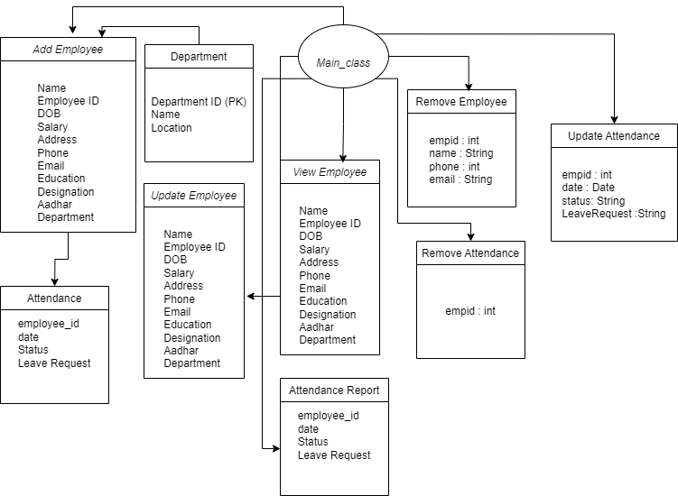

Entity-Relationship (ER) Diagram

The ER diagram represents relationships between entities such as Employee, Attendance, and other related tables, illustrating how attendance records are tied to employee IDs.
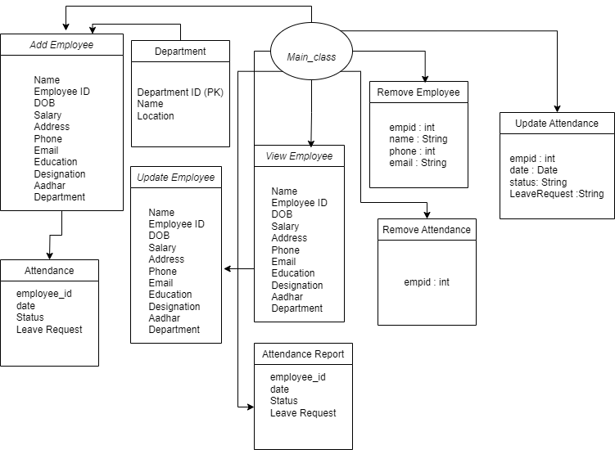

Gantt Chart

The Gantt Chart outlines the timeline for project phases such as system design, implementation, testing, and deployment.
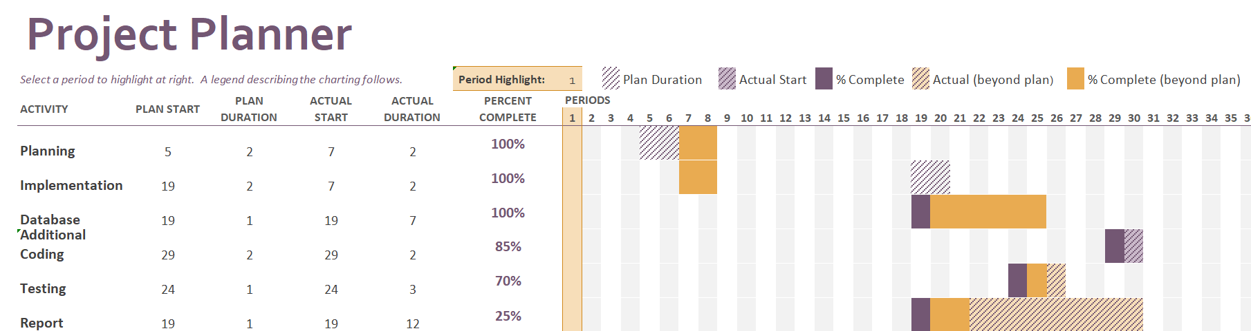

4. Implementation

Modules/Features

- Add Employee
- Capture employee details: name, CNIC, designation, salary, qualification, phone number, and email.
- Automatically generate a unique employee ID.
- Link employee details with attendance records in the database.

- View Employee
- Retrieve and display employee information, including linked attendance records.
- Search for employees by employee ID or other details.

- Update Employee
- Update fields such as designation, salary, and contact details.
- Ensure all changes are reflected in both employee and linked attendance records.

- Remove Employee
- Remove employee records from the database.
- Automatically delete corresponding attendance records when an employee is removed.

- Attendance Tracking
- Record daily attendance, including status (present/absent), leave requests, and dates.
- Link attendance records to employee IDs.

5. Testing

Testing Approach

- Unit Testing: Tested each method individually, including the `generateEmployeeID()` and `recordAttendance()` methods.
- Integration Testing: Ensured that changes in employee data are accurately reflected in attendance records.
- System Testing: Verified overall system functionality.

Test Cases

- Add Employee
- Test Scenario: Add an employee with all valid details.
- Expected Output: Employee added successfully, and details are correctly stored.
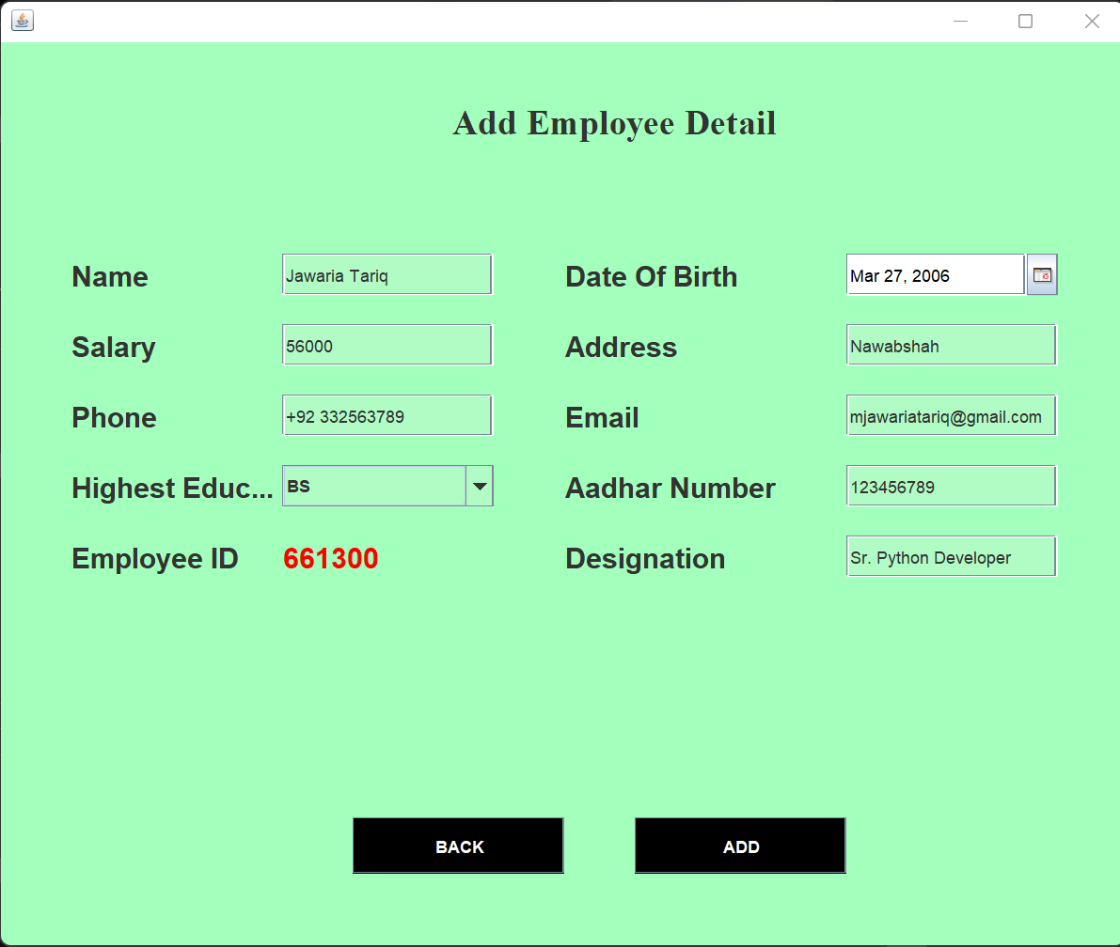

- Update Employee
- Test Scenario: Update the phone number and salary for an existing employee.
- Expected Output: Employee details updated successfully.
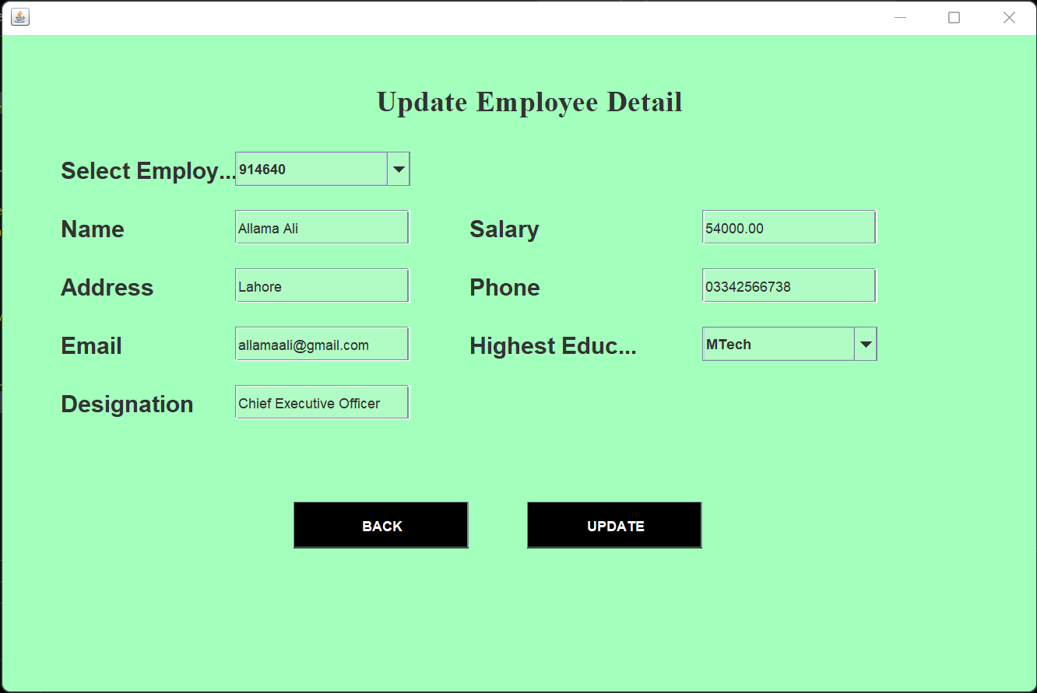

- Remove Employee
- Test Scenario: Remove an employee using their employee ID.
- Expected Output: Employee and corresponding attendance records are deleted.
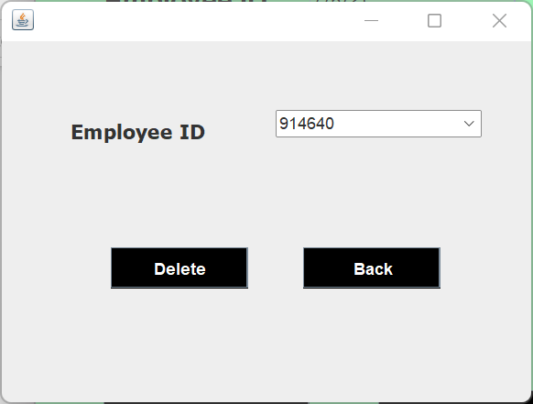

View Employee
Test Scenario: View employee details using the employee ID.
Expected Output: Employee details are accurately displayed, including linked attendance records.
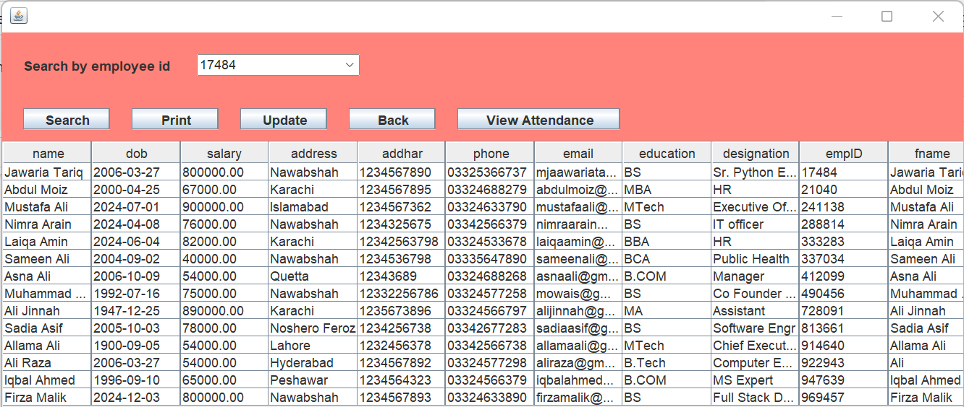
- Attendance Report
Test Scenario: Generate an attendance report for a specific employee.
Expected Output: Attendance report is generated correctly, showing all recorded dates and attendance statuses for the employee.

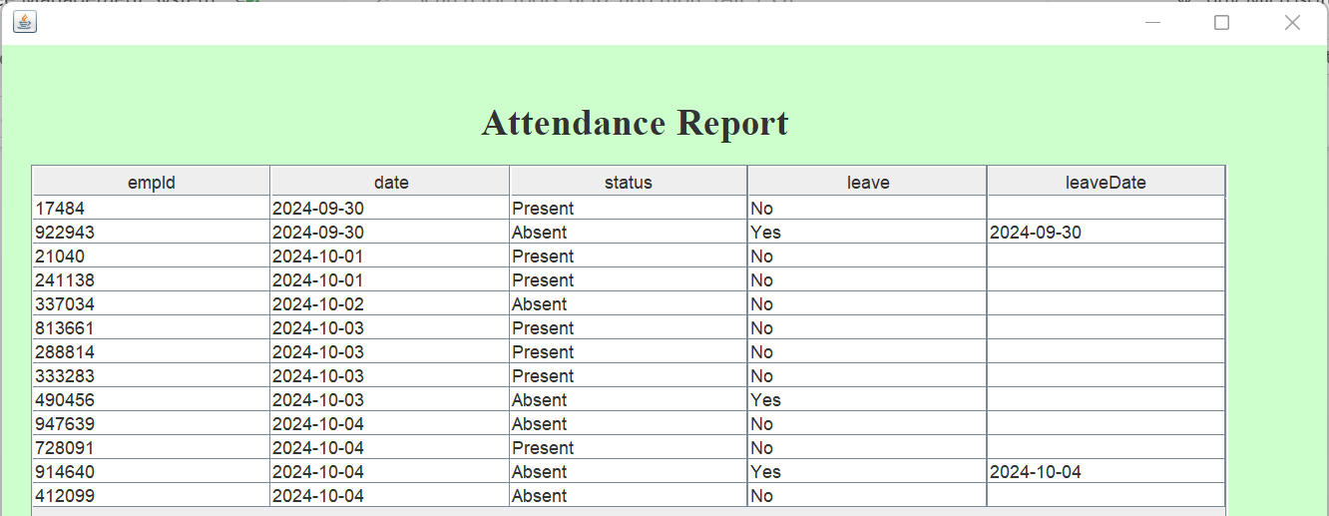
- Record Attendance
- Test Scenario: Record attendance for an employee for a specific date.
- Expected Output: Attendance status correctly recorded and linked to the employee.

The Employee Management System simplifies employee data and attendance tracking, ensuring data integrity and reducing manual errors. The system is scalable, allowing for future enhancements such as salary processing and performance evaluation.
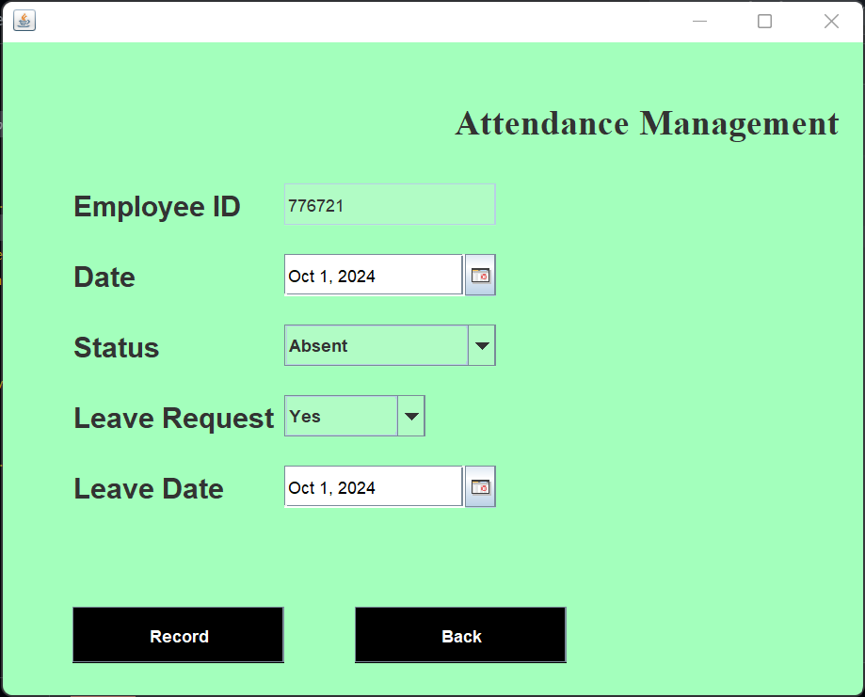

-Update Attendance
Test Scenario: Update attendance for an employee for a specific date.
Expected Output: Attendance status is updated successfully for the given date and reflects accurately in the system.

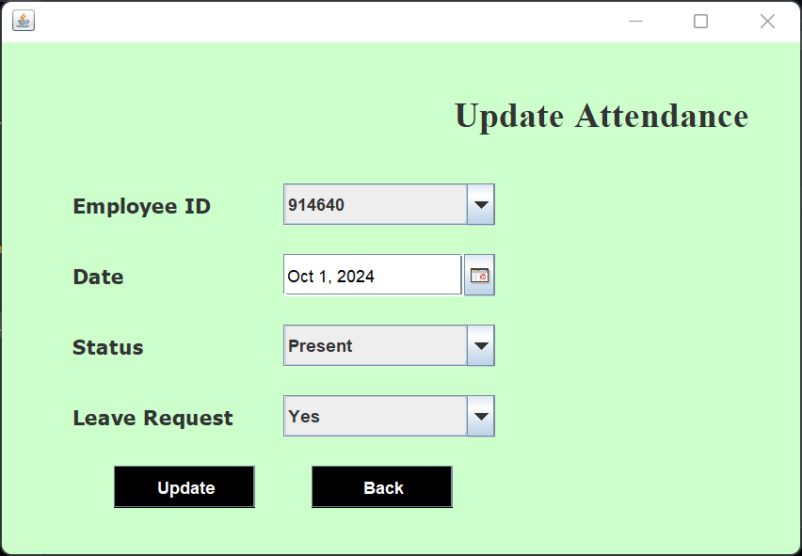

-Remove Attendance
Test Scenario: Remove attendance record for a specific date.
Expected Output: Attendance record is deleted successfully, and the system no longer displays the removed attendance entry.
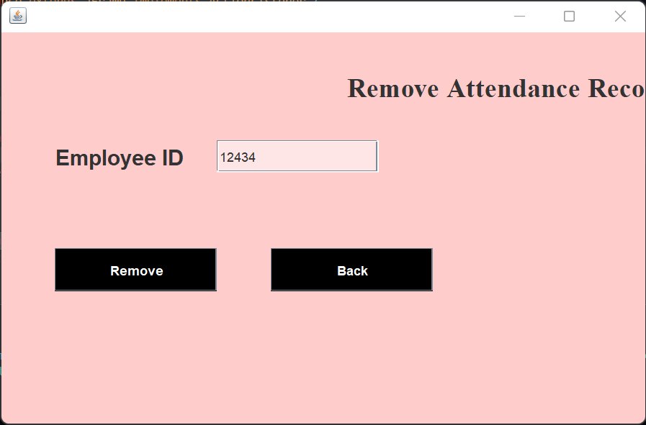

7. Future Enhancements

- Salary Calculation Module: Automate payroll management based on attendance and employee data.
- Performance Evaluation: Integrate performance tracking features to monitor employee productivity.
- Backup Management: Add a feature for regular database backups to ensure data security.

---

